Introduction
Larin, K.V.
University of Houston
email: klarin@uh.edu
Reliable assessment of tissue biomechanics is crucial for understanding physiological and pathological processes. Optical elastography methods—particularly Optical Coherence Elastography (OCE) and Brillouin imaging—are emerging as powerful, high-resolution tools for this purpose. However, the quantitative relationship between these optical methods and established mechanical or ultrasound-based techniques remains insufficiently characterized.
Here, I will present a comprehensive comparative study of multiple elastography modalities, including wave-based air-pulse OCE, air-coupled ultrasound (ACUS) OCE, piezoelectric (PZT) OCE, compression OCE, ultrasound shear wave elastography (USWE), and Brillouin imaging, benchmarked against uniaxial mechanical testing. Tissue-mimicking gelatin phantoms of varying stiffness (12–16% w/v) were used to evaluate measurement accuracy, repeatability, and inter-method agreement (Figure 1).
Wave-based OCE techniques demonstrated strong consistency with mechanical testing, exhibiting mean errors below 11%. USWE showed the smallest average deviation (7.5% ± 2.8%) and excellent repeatability. Brillouin imaging exhibited a high correlation with mechanical testing results (R = 0.96), confirming its sensitivity to stiffness variations despite its indirect relation to Young’s modulus. Bland–Altman analysis revealed no significant bias for all dynamic elastography techniques except compression OCE (Figure 2).
This systematic comparison provides a quantitative framework for cross-validating optical and acoustic elastography approaches. Our findings emphasize the need for standardized calibration protocols to achieve reliable, reproducible biomechanical imaging across modalities and lay the groundwork for translating optical elastography and Brillouin imaging into clinical applications.

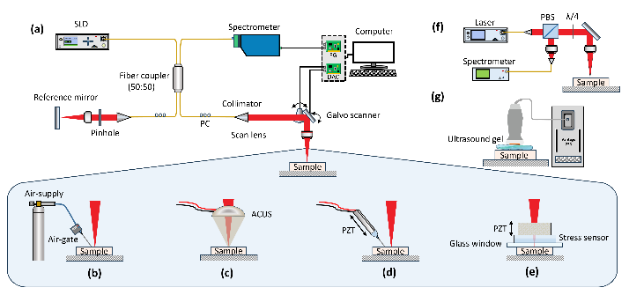
Figure 1 (a) Schematic of SD-OCT System used for OCE and the various excitation modalities; DAC: Digital to analog convertor; FG: frame grabber; PC: polarization controller; SLD: superluminescent diode, (b) Air pulse (AP)-OCE, (c) Air coupled ultrasound (ACUS)-OCE, (d) piezoelectric (PZT)-OCE, (e) Compression OCE, (f) Brillouin Imaging, (g) Ultrasound-based shear wave elastography (USWE).

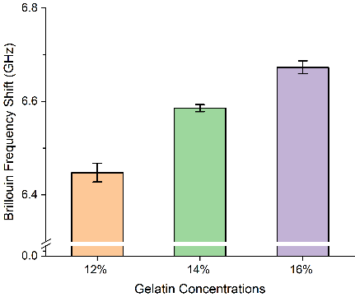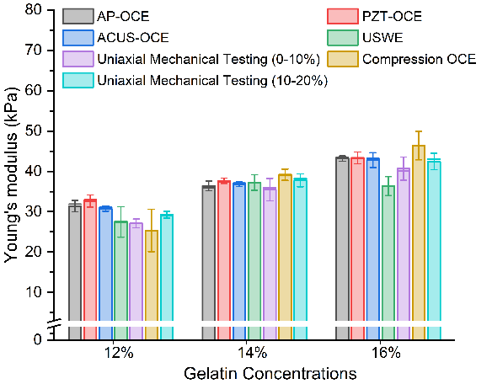
Figure 2 (a) Brillouin frequency shift measured for gelatin phantoms of varying concentrations. The error bar represents the standard deviation with n=3 samples for each concentration. (b) Comparison of measured Young’s moduli from different elastography methods for gelatin phantoms of varying concentrations. The error bars represent the standard deviation with n=3 samples for each concentration.

Comparative Analysis of Several Elastography Techniques for Tissue Biomechanics

