Introduction
The structural response of a biological system to perturbations can be extremely rapid on the microscopic scale (e.g depolarization of a cell). Measuring the dynamics of BLS spectra during and following such perturbations can provide insight into transient phase changes and mechano-transduction/transmission mechanisms that may underlie fundamental biological processes.
Many biological systems on account of their underlying structure are mechanically anisotropic on the microscopic scale. Measuring the 3D anisotropy of the mechanical properties with sub-cellular resolution is essential for a complete understanding of the mechanical context of biological systems and the dynamics associated with numerous biological processes
Here we present two new Brillouin Light Scattering (BLS) spectroscopy approaches that address the above:
(1) co-localized angle-resolved BLS microscopy (colar-BM): Can measure the 3D anisotropy of the hypersonic speed and attenuation in biological samples, employing an off-the-shelf Virtual Imaged Phased Array.
(2) ultrafast stimulus-synchronized BLS microscopy (uss-BM): Can measure transient changes in the hypersonic speed and attenuation in biological samples that occur over time scales as small as ~10 ps.

Materials, methods & Results
Both colar-BM and uss-BM spectrometers are imaging-spectrometers based on the VIPA architecture. Both techniques rely on “spontaneous” Brillouin light scattering at visible wavelengths.
The colar-BM spectrometer exploits the conservation of angular information when light propagates through a VIPA etalon. In particular that light from every solid-angle increment collected by a high-NA objective lens will have a one to one correspondence to a position on the 2D spectral projection from a VIPA. Unlike previous single-shot angle-resolved BLS approaches (e.g. Keshmiri et al. 2024), collar-BM, allows for: (A) the reconstruction of the 3D anisotropy (spanning polar and azimuthal angles), and not only the 2D anisotropy (azimuthal angles). This is important for understanding processes occurring in 3D and unambiguously identifying symmetry classes of anisotropic biological matter. (B) the use of commercially available VIPA’s allows for its relatively easy implementation by making minor modifications to a conventional VIPA-based BLS spectrometer.
Figure 1a shows the principle of the colar-BM spectrometer: the signal collected on the detector can be interpreted both as a power spectral density by using the iso-curves of frequency or as points related to a particular angle of collection of the objective using a geometrical optics approach of the system. Figure 1b uses this approach to interpret the Brillouin scattered light collected on a sample of glycerol, namely the Brillouin shift as a function of the polar angle of collection of the objective.
The uss-BM spectrometer, works on the principle of integrating the BLS-scattered light at the same time-delay following a repeated time trigger. The time trigger could be from an induced perturbation (electrical-stimulation/depolarization, mechanical shock/poke, etc.) or from any other naturally occurring event (such as optical, electric, etc. detection of a repeated processes). The timing of the time-trigger (time stamps) does not need to be periodic, yet one needs to be able to assume that the processes are fully reversible (i.e. the system has an equivalent dynamic response following each time stamp). In brief, the setup involves projecting the spatially dispersed BLS spectra into the slit of streak camera. The sweep times of the latter are triggered by the time trigger (with an optional delay). This results in a 2D spatial projection on an EM-CCD camera (output of streak camera), containing the time-evolution (y-axis) of the BLS spectra (x-axis). The time window can be adjusted (via the sweep rates) to be between 1ns and 1ms, allowing one to observe changes in the BLS spectra with a resolution of <10ps. The EM-CCD acquisition time is such that this 2D BLS spectra is integrated over many trigger times (milliseconds to hours), with the photon statistics and SNR improving with increased integration time.
I will discuss the principles of the above two approaches, details of their experimental implementation and results from proof of principle demonstrations. I will also discuss some current and planned applications in studying ultra-fast mechanics of biological processes and structural changes in biological cells and tissue.
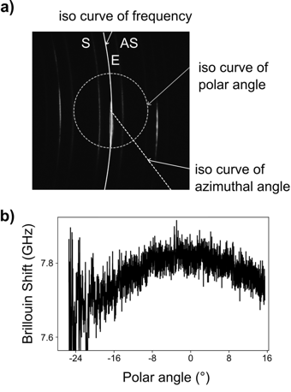
Figure 1 Proof of concepts of the colar-BM . Panel (a) show the correspondence of the interference spectrum obtained with a VIPA spectrometer and the angular components of a Brillouin scattered signal obtained on Glycerol. Panel (b) plots the Brillouin shift of the same Glycerol sample as a function of polar angle measured using colar-BM.

