Offshore instrumentation operates in some of the most demanding environments on the planet, and this exposure introduces several significant limitations. Saltwater corrosion, extreme temperatures, high humidity, and constant mechanical stress from waves and currents can degrade sensors and housings, reducing accuracy and shortening equipment lifespan. Biofouling can obstruct sensors, interfere with readings, and increase maintenance needs. Power supply is another constraint, as many offshore instruments rely on batteries or intermittent renewable energy sources, making long-term autonomous operation challenging. Data transmission can also be limited by distance from shore, bandwidth restrictions, or the need for expensive satellite communication systems. Operational and logistical challenges associated to the deployment, calibration, and retrieval of sensors further complicates conventional offshore measurements.
Gonzalez-Herraez, M.^{1,2}
¹ Instituto de Óptica, Consejo Superior de Investigaciones Científicas (CSIC). C/ Serrano 121, Madrid 28006. Spain
² Sensors and Photonic Technologies, Universidad de Alcalá. Associate Unit to CSIC by Institute of Optics. Escuela Politécnica Superior, Campus Externo. Alcalá de Henares, Madrid 28806. Spain.
email: miguel.gonzalez.herraez@csic.es

Existing submarine telecommunications cables can now serve as powerful ocean sensing platforms through optical fibre–based sensing techniques such as Rayleigh-based Distributed Acoustic Sensing (DAS) and Brillouin-based Distributed Temperature Sensing (DTS). These systems transform available fibre-optic cables—already crossing vast ocean areas—into dense, continuous sensor arrays without requiring new seafloor infrastructure. This dramatically reduces deployment costs, eliminates many logistical constraints, ensures long-term durability and provides immunity to corrosion, electrical interference, and biofouling. Since the fibre acts simultaneously as sensor and transmission medium, there is no need for offshore power sources or local data loggers. The sensitivity and spatial coverage achievable with these systems can far exceed that of conventional point sensors, providing measurements over tens to thousands of kilometres with meter-scale resolution. This paper reviews some of the first demonstrations of distributed optical fibre sensing in the oceans. We show that this kind of instrumentation is a very good alternative for offshore geophysical monitoring, as well as for monitoring calls of large mammals (fin whales, blue whales, etc.)
We report here some observations employing our custom-made DAS and DTS units in the existing submarine telecommunication cable that is deployed between the islands of Tenerife and Gran Canaria, in the Atlantic Ocean. The submarine cable has a total length of ~176 km and lies over the seafloor reaching a maximum depth of 3,570 m below sea level.
(a)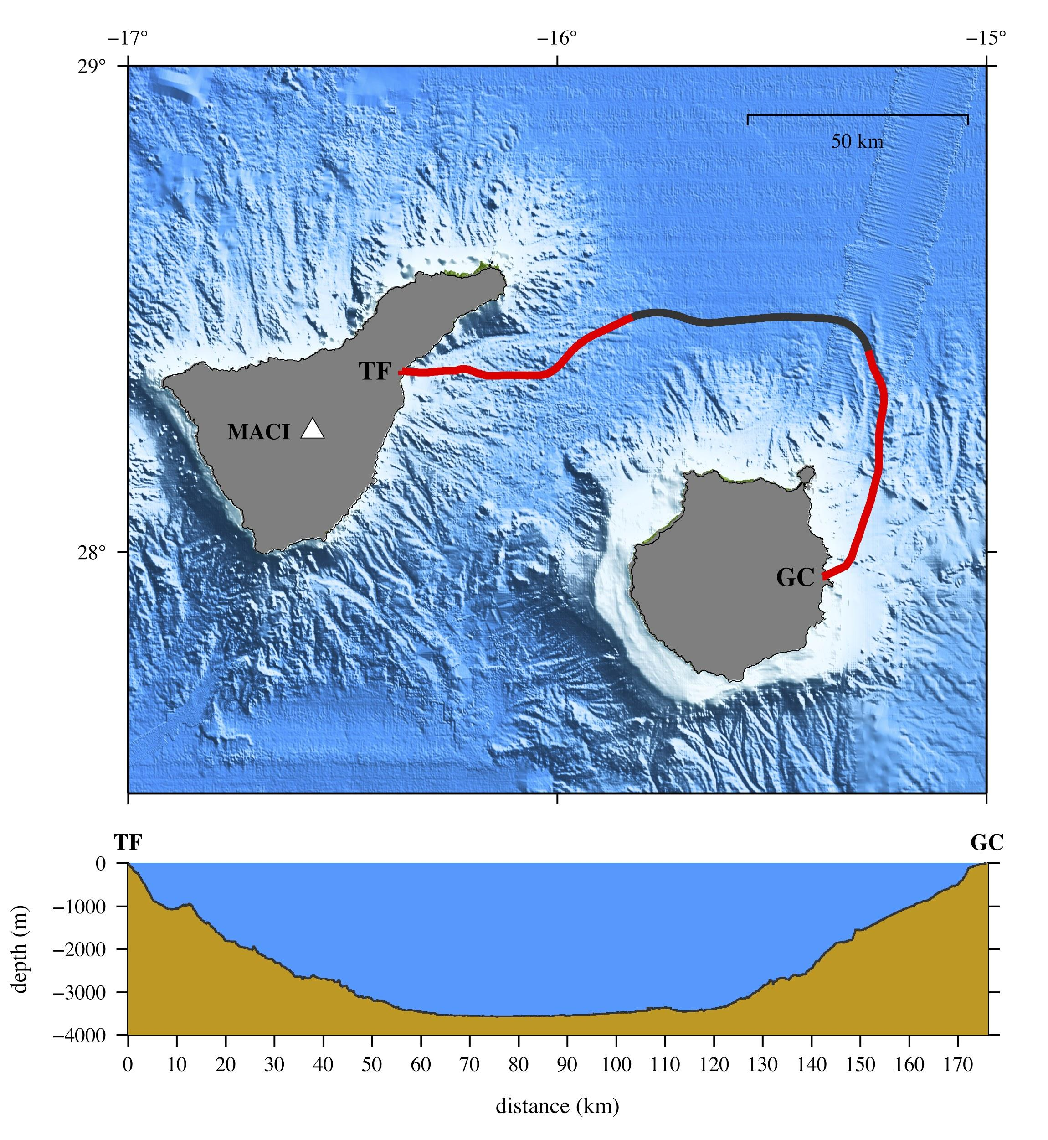
(b)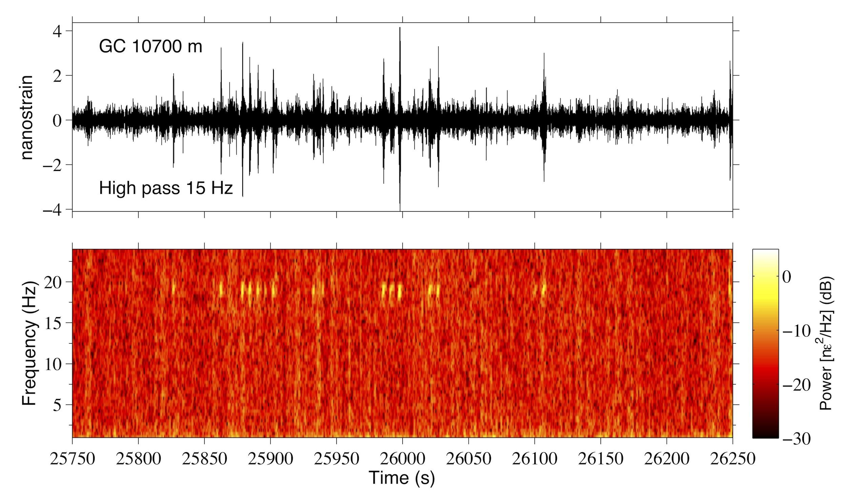
(c)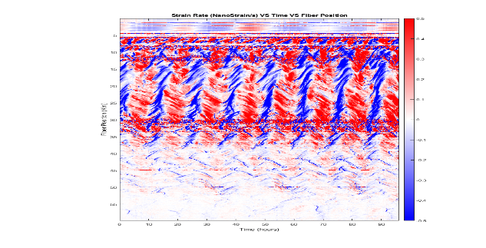
Fig 1: (a) cable layout and associated bathymetry; (b) example of fin whale vocalizations recorded on the cable; (c) observation of internal waves along the cable

References:
- Ugalde et al. Seismological Research Letters 93 (1): 351–363. (2022)
- Williams et al. Journal of Geophysical Research: Oceans, 128, e2023JC019980 (2023).

