Introduction
Saeidi Fard, S.¹, Ramachandran, V.², Nevozhay, D.³, Aglyamov, S.¹, Kim, M.², Larin, K.¹, Sokolov, K.³
¹ Department of Biomedical Engineering, University of Houston, Houston, TX, 77204
² Department of Surgical Oncology, The UT M.D. Anderson Cancer Center, Houston, TX, 77030
³Department of Imaging Physics, The UT M.D. Anderson Cancer Center, Houston, TX, 77030
email: ksokolov@mdanderson.org

Pancreatic ductal adenocarcinoma (pancreatic cancer, PDAC) is the classic example of a recalcitrant tumor that is extremely challenging to treat. It is one of the most aggressive malignancies, with a yearly incidence that equals its mortality.¹ The only chance for a cure is surgical resection, but only 15-20% individuals have resectable disease.² Despite radical surgery, the overall survival (OS) rate for patients with localized disease is ~20%. Systemic chemotherapy treatment with gemcitabine (Gem) is one of the first-line therapies, but this treatment only achieves a modest increase in patients’ survival. Recent emergence of targeted inhibitors and stroma-targeting modulators provides new frontiers in PDAC treatment and opportunities for personalized therapy.³ However, methods for assessing the most effective therapy for a specific patient are lacking.
It has been demonstrated that the interplay between the stroma and pancreatic cancer cells plays a crucial role in PDAC biology and drug resistance.⁴ We hypothesize that these changes will be associated with alterations in PDAC biomechanical properties that could be used as a biomarker of a treatment response. To test this hypothesis, we apply Brillouin microscopy to study chemotherapy induced changes in stiffness of organoids derived from pancreatic cancer patients.
Materials and methods
3D patient derived organoids (PDOs) were prepared as described in³. PDOs were treated with 100 nM Gem for three days. The untreated PDOs were grown in culture media without the drug as a control. PDOs were grown to sizes ranging from approximately 50 to 200 µm before the start of the treatment.
The Brillouin microscopy system was previously described in⁵. Briefly, it utilized 660 nm single longitudinal mode laser (Torus, Laser Quantum Inc., CA) and a two-stage virtually imaged phased array (VIPA) spectrometer. We used water calibration from the sample arm and acetone calibration form the reference arm.

results and discussion
The treated PDOs from two different patients (i.e., PDX3 and PDX4) showed a significant decrease in the overall stiffness (longitudinal modulus) as compared to the untreated controls (Figure 1). These results indicate that Brillouin imaging can provide a critically needed tool for a robust assessment of PDAC therapy.
In parallel with the biomechanical measurements, we carry out metabolic imaging using two-photon microscopy of FAD and NAD(P)H to study drug-induced mechano-metabolic disruptions. Further, we plan to evaluate cell transcriptomics to get mechanistic insights into the observed biomechanical changes and to get a better understanding of correlation between PDAC biomechanics and the treatment response. Overall, these studies are aimed at development of predictive biomarkers of patient’s response to new lines of pancreatic cancer therapies.
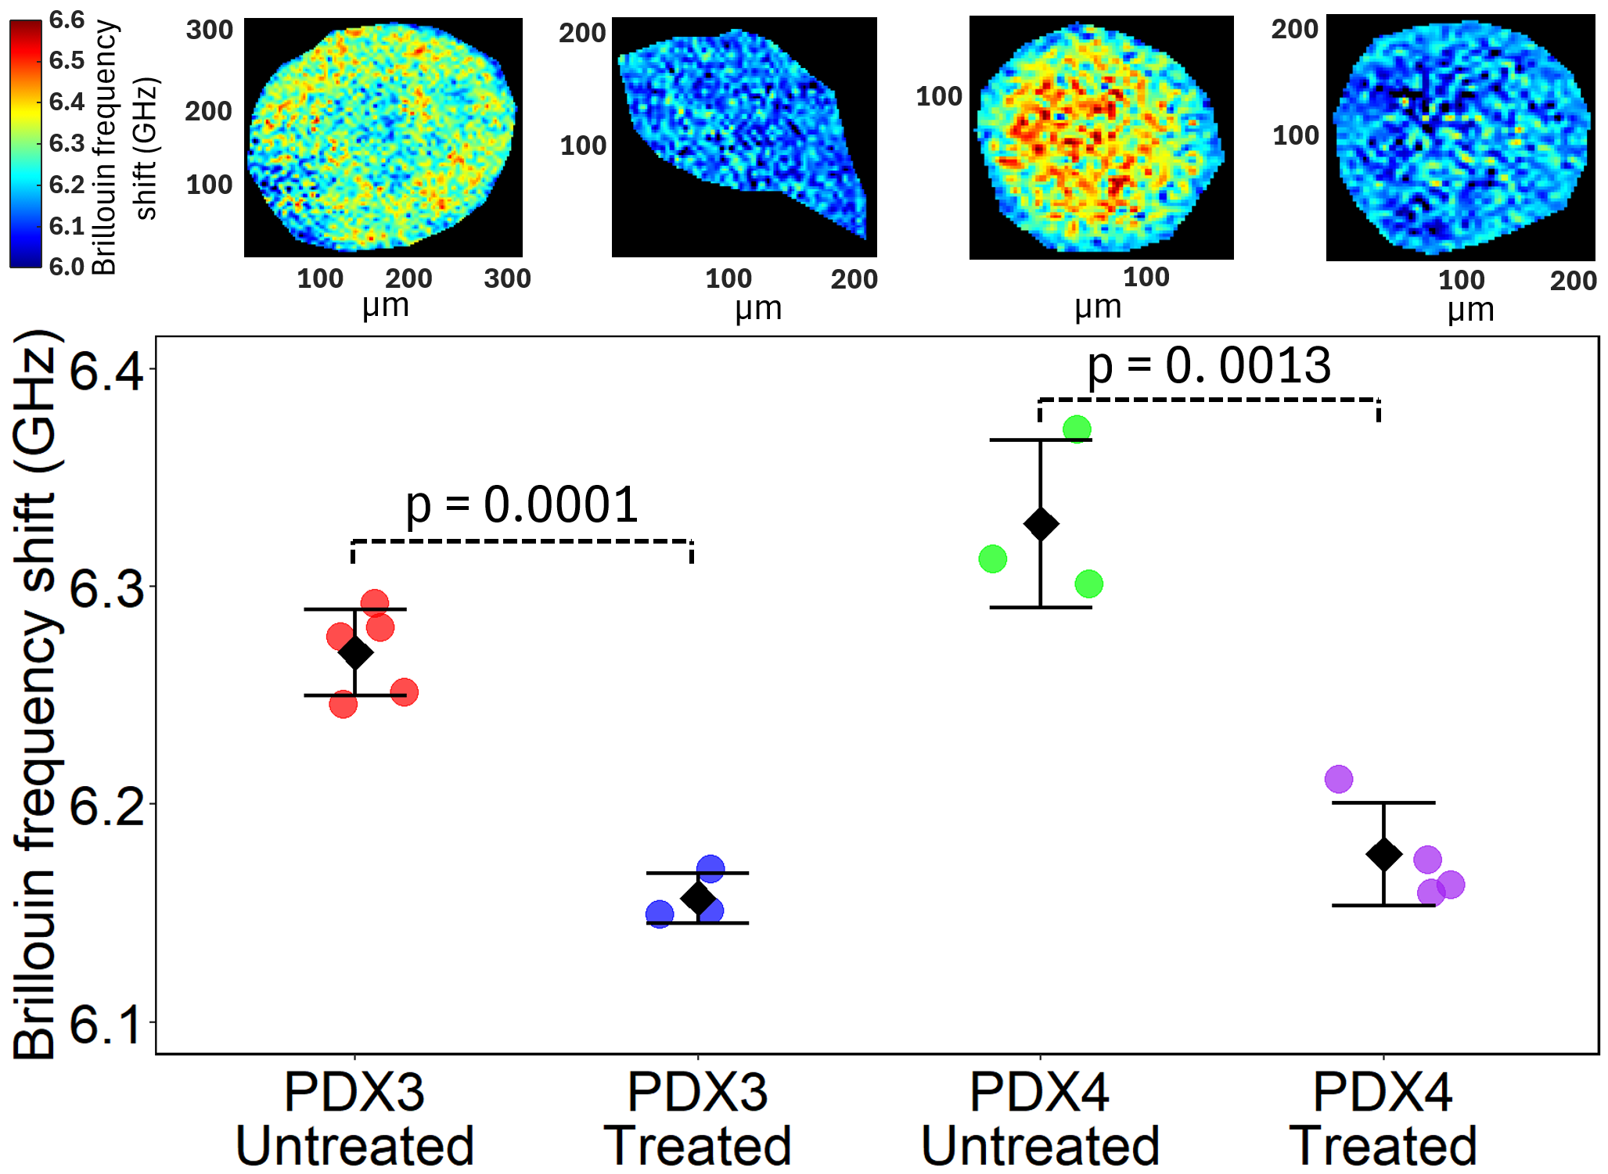
Figure 1 Top: Representative Brillouin shift images of two patient derived organoids (PDX3 and PDX4) before and after 3-day treatment with 100 nM gemcitabine (Gem). The organoid dimensions are 150-300 µm. Bottom: Comparison of Brillouin shift measurements between treated and untreated PDOs.

Evaluation of changes in biomechanics of pancreatic cancer in response to therapy using Brillouin imaging

References
1. Jemal, A. (et al.), CA Cancer J Clin 56: 106-130, 2006.
2. Sener, S.F. (et al.), J Am Coll Surg 189: 1-7, 1999.
3. Kang, Y. (et al), J Clin Invest 132: 1-15, 2022.
4. Hosein, A.N. (et al.), Nat Rev Gastroenterol Hepatol 17: 487-505, 2020.
5. Mendieta, M. (et al.), IEEE Open Journal of Engineering in Medicine and Biology, 1-10, 2025.

