A standardized file format and open-source analysis framework for Brillouin microscopy data
Carlo Bevilacqua^{1,*}, Sebastian Hambura^{1,*}, Pierre Bouvet^{2,*}, Salvatore La Cavera III³, Kareem Elsayad^{2,*,#}, and Robert Prevedel^{1,4,*,#}
¹Cell Biology and Biophysics Unit, European Molecular Biology Laboratory, Heidelberg, Germany.
²Center for Anatomy and Cell Biology, Medical University of Vienna, Vienna, Austria.
³Optics & Photonics Group, Faculty of Engineering, University of Nottingham, Nottingham, UK.
⁴German Center for Lung Research (DZL), Heidelberg, Germany.
*Contributed equally. #Corresponding authors.
Brillouin microscopy is rapidly emerging as a powerful technique for imaging the mechanical properties of biological specimens in a label-free, non-contact manner. We present a standardized file format and open-source tools to facilitate the uptake and analysis of Brillouin microscopy related data and to unify this growing field.
Brillouin microscopy allows for 3D mapping of the viscoelasticity in living cells and tissue with a high spatio-temporal resolution^{1,2}. It is based on inelastic scattering – so-called Brillouin Light Scattering (BLS)³ – that results from the interaction of photons with propagating thermally induced or stimulated MHz-GHz acoustic waves (acoustic phonons). The frequency or time shift of this scattered light relative to the elastic scattered light, and its spectral-width or attenuation, are directly related to the material’s longitudinal elastic and viscous moduli^{1,3,4}. For certain implementations, the intensity and angle dependence of the BLS scattering can also be used to estimate the mass density⁵ and the refractive index^{6,7}. Over the past decade, it has found increasing applications for studying cell and tissue mechanics in development and disease, as well as for the physical characterization of biomaterials, largely on accounts of improvements in the required ultra-high resolution spectrometer designs^{1,2,8,9}.
Despite its growing adoption, the Brillouin microscopy community faces a critical bottleneck: the lack of standardized methods for storing, sharing, and analyzing spectral data and associated metadata. This limits reproducibility and hampers cross-study and cross-lab comparisons — challenges that become increasingly acute as the field as well as number and diversity of users increases¹⁰.
In Brillouin images, each spatial position (voxel) is associated with a spectrum over a finite spectral range (typically a few to 10s of GHz) in the vicinity of the probing laser frequency (Fig. 1a). What is generally of interest is the position, shape, intensity and width of the spectrum which can be composed of a single Brillouin peak, or in case of heterogenous materials, combination of multiple peaks, which are fitted using established models to obtain values for the viscoelastic parameters. The useful information is generally contained in the rendered spatial maps of these fitted parameters for each voxel. The diverse modalities for measuring and analyzing the Brillouin spectrum can lead to significant variability in reported values for the same specimen¹⁰. It is thus a high priority to establish standardized analysis protocols, pipelines and file formats to increase reproducibility and enable meaningful comparisons, especially since relevant parameter changes are often only a few percent.
To address this need, we propose a standardized file format and accompanying open-source software suite for Brillouin microscopy. Our framework supports data from the diverse range of Brillouin microscope implementations — including spontaneous and stimulated scattering, confocal and line-scanning modalities, and time- or frequency-domain detection — offering a unifying and intuitive, easy-to-use solution for both custom-built as well as commercial systems. To showcase this ability, we provide example datasets from diverse Brillouin modalities (Supplementary Information).
We advocate for the use of a standardized file format, .brim, a hierarchical, cloud-compatible format based on Zarr v3 that is already gaining traction in bioimaging and genomics¹¹. Zarr provides efficient storage of large multi-dimensional arrays alongside rich metadata and supports both local and remote data access. Our proposed structure accommodates spectral data, processed outputs (e.g. Brillouin shift and linewidth maps), and relevant acquisition and optional post-processing metadata, together with the corresponding raw data. The design ensures machine readability and future-proofing through explicit versioning and extensible subtypes. We further highlight a complementary file format, .brimX, for storing complex multi-parameter biophysical studies that generalize beyond individual or a single series of spatial maps/images. The .brimX format can save entire experiments or projects (e.g. measurements series of different mutants, conditions, etc.) in a single self-contained annotated file, from which select .brim files can easily be extracted using a provided open-source conversion library (BrimConverter). This is particularly useful for archiving purposes and sharing large multi-parameter studies in collaborative projects. The adoption of these two common formats can thus broadly cater to all of the Brillouin light-scattering spectroscopy community.
To promote adoption and ease of use, we developed two complementary Python-based packages (see Supplementary Information):
- Brimfile, optimized for bioimaging use cases, supports straightforward saving of spectral data as well as analysis/processing results into the standardized .brim format together with the relevant metadata; conversely it also facilitates reading such data from an existing .brim file.
- HDF5_BLS, tailored to seamlessly integrate into existing Python workflows to create and export standardized HDF5 file formats for all BLS modalities.
These two packages, optimised for both efficiency and flexibility respectively, complement each other through a conversion library integrated into both called BrimConverter, and permits reformatting and restructuring between .brim and .brimX files. To allow the use of established image analysis tools on the derived spatial maps (eg. shift, width, amplitude, etc.) both brimfile and HDF5_BLS support export to widely adopted formats such as OME-TIFF¹². To further facilitate uptake, we also developed a Napari plugin to open such maps directly from a .brim file (see Supplementary Information).
For spectra visualization and analysis we developed BrimView, a modular, browser-based GUI (developed using Panel/Holoviz) that facilitates the visual representation of derived spatial maps of e.g. shift, width, amplitude, etc., together with the corresponding spectral data. BrimView integrates a package we developed called Treat which enables processing of the spectra, supporting multiple fitting models (e.g., Lorentzian, DHO, Voigt) of single or overlapping peaks, and including the option to account for the instrument spectral response function. All the metadata required to make the processing reproducible can be stored in the file. Furthermore, BrimView can be run online without requiring local software installation, lowering the adoption barrier for non-expert users. Additionally, the possibility of loading files directly from the cloud further fosters data sharing in the community.
All combined, our infrastructure enables reproducible, transparent analysis workflows and fosters FAIR (Findable, Accessible, Interoperable, Reusable) data practices¹³. Crucially, the standardized format ensures that essential metadata—such as optical configuration, calibration parameters, and fitting assumptions—are preserved and shareable, addressing a major shortcoming in the field, where such information in current publications is often absent or non-machine-readable¹⁰. We envision this effort as a starting point for a community-driven Brillouin data management ecosystem. Our software is fully open-source, and the file format specifications are hosted on GitHub to encourage feedback, extensions, and broad adoption (see Supplementary Information). We believe this standardization initiative is a critical step for Brillouin microscopy to transition from niche technology to a mainstream bioimaging tool. It will facilitate data sharing and comparative analysis across labs, accelerate method development, and increase the impact and accessibility of published studies. We welcome collaboration from the broader microscopy and bioimaging communities as we work toward integration with existing standards, including the OME data model¹⁴ and broader microscopy metadata efforts, such as REMBI¹⁵. We note that the presented framework can, with suitable customizations, also be adopted for other multi-dimensional hyperspectral datasets beyond Brillouin microscopy as well as for correlating Brillouin microscopy studies with complementary techniques (Raman, fluorescence, etc.). Finally, with the first commercial Brillouin microscopes suitable for routine life-science applications coming to the market, we emphasise the timeliness of establishing a broad adoption of open-source standards, and strongly encourage compatibility with the proposed platform by commercial stakeholders.
Correspondence should be addressed to Kareem.Elsayad@meduniwien.ac.at and prevedel@embl.de.
Data availability. Sample data are available at https://storage.googleapis.com/brim-example-files. Exemplary imaging data presented in figures are available upon request.
Code availability.
Software | Source code | Documentation
BrimView (https://biobrillouin.org/brimview/) | https://github.com/prevedel-lab/BrimView
brimfile | https://github.com/prevedel-lab/brimfile | https://prevedel-lab.github.io/brimfile/
HDF5_BLS | https://github.com/bio-brillouin/HDF5_BLS | https://github.com/bio-brillouin/HDF5_BLS/blob/main/guides/Tutorial/Tutorial.pdf
HDF5_BLS_treat | https://github.com/bio-brillouin/HDF5_BLS/tree/main/HDF5_BLS_treat | https://hdf5-bls.readthedocs.io/en/latest/source/modules.html
Queries and feedback can be provided by creating an issue on GitHub. Documentation is provided in the Supplementary Information (and is kept up to date at https://prevedel-lab.github.io/brimfile/brimfile.html).
References
1. Prevedel, R., Diz-Muñoz, A., Ruocco, G. & Antonacci, G. Brillouin microscopy: an emerging tool for mechanobiology. Nat. Methods 16, 969–977 (2019).
2. Kabakova, I. et al. Brillouin microscopy. Nat. Rev. Methods Prim. 4, 8 (2024).
3. Berne, B. J. & Pecora, R. Dynamic Light Scattering: With Applications to Chemistry, Biology, and Physics. (Dover Publications, 2000).
4. Palombo, F. & Fioretto, D. Brillouin Light Scattering: Applications in Biomedical Sciences. Chem. Rev. 119, 7833–7847 (2019).
5. Remer, I., Shaashoua, R., Shemesh, N., Ben-Zvi, A. & Bilenca, A. High-sensitivity and high-specificity biomechanical imaging by stimulated Brillouin scattering microscopy. Nat. Methods 17, 913–916 (2020).
6. Fiore, A., Bevilacqua, C. & Scarcelli, G. Direct three-dimensional measurement of refractive index via dual photon-phonon scattering. Phys. Rev. Lett. 122, 103901 (2019).
7. Koski, K. J., Akhenblit, P., McKiernan, K. & Yarger, J. L. Non-invasive determination of the complete elastic moduli of spider silks. Nat. Mater. 12, 262–267 (2013).
8. Scarcelli, G. et al. Noncontact three-dimensional mapping of intracellular hydromechanical properties by Brillouin microscopy. Nat. Methods 12, 1132–1134 (2015).
9. Poon, C., Chou, J., Cortie, M. & Kabakova, I. Brillouin imaging for studies of micromechanics in biology and biomedicine: from current state-of-the-art to future clinical translation. J. Phys. Photonics 3, 012002 (2020).
10. Bouvet, P. et al. Consensus statement on Brillouin light scattering microscopy of biological materials. Nat. Photonics 19, 681–691 (2025).
11. Moore, J. et al. OME-Zarr: a cloud-optimized bioimaging file format with international community support. Histochem. Cell Biol. 160, 223–251 (2023).
12. Besson, S. et al. Bringing Open Data to Whole Slide Imaging. in 3–10 (2019). doi:10.1007/978-3-030-23937-4_1.
13. Wilkinson, M. D. et al. The FAIR Guiding Principles for scientific data management and stewardship. Sci. Data 3, 160018 (2016).
14. Goldberg, I. G. et al. The Open Microscopy Environment (OME) Data Model and XML file: open tools for informatics and quantitative analysis in biological imaging. Genome Biol. 6, R47 (2005).
15. Sarkans, U. et al. REMBI: Recommended Metadata for Biological Images—enabling reuse of microscopy data in biology. Nat. Methods 18, 1418–1422 (2021).

Acknowledgements
The authors wish to thank Jean-Karim Hériché (EMBL) for helpful discussions. C.B., S.B. and R.P. acknowledge funding from the EMBL, an ERC Consolidator Grant (grant no. 864027, Brillouin4Life) and the German Center for Lung Research (DZL). P.B. and K.E. acknowledge funding from the Medical University of Vienna, Austrian Science Foundation FWF (grant no. P34783) and funding from the EU - Recovery and Resilience Facility (RRF). S.L. acknowledges funding from the Royal Academy of Engineering Research Fellowships scheme (grant no. RF-2324-23-223) and the Nottingham Research Fellowship scheme.

Figure 1
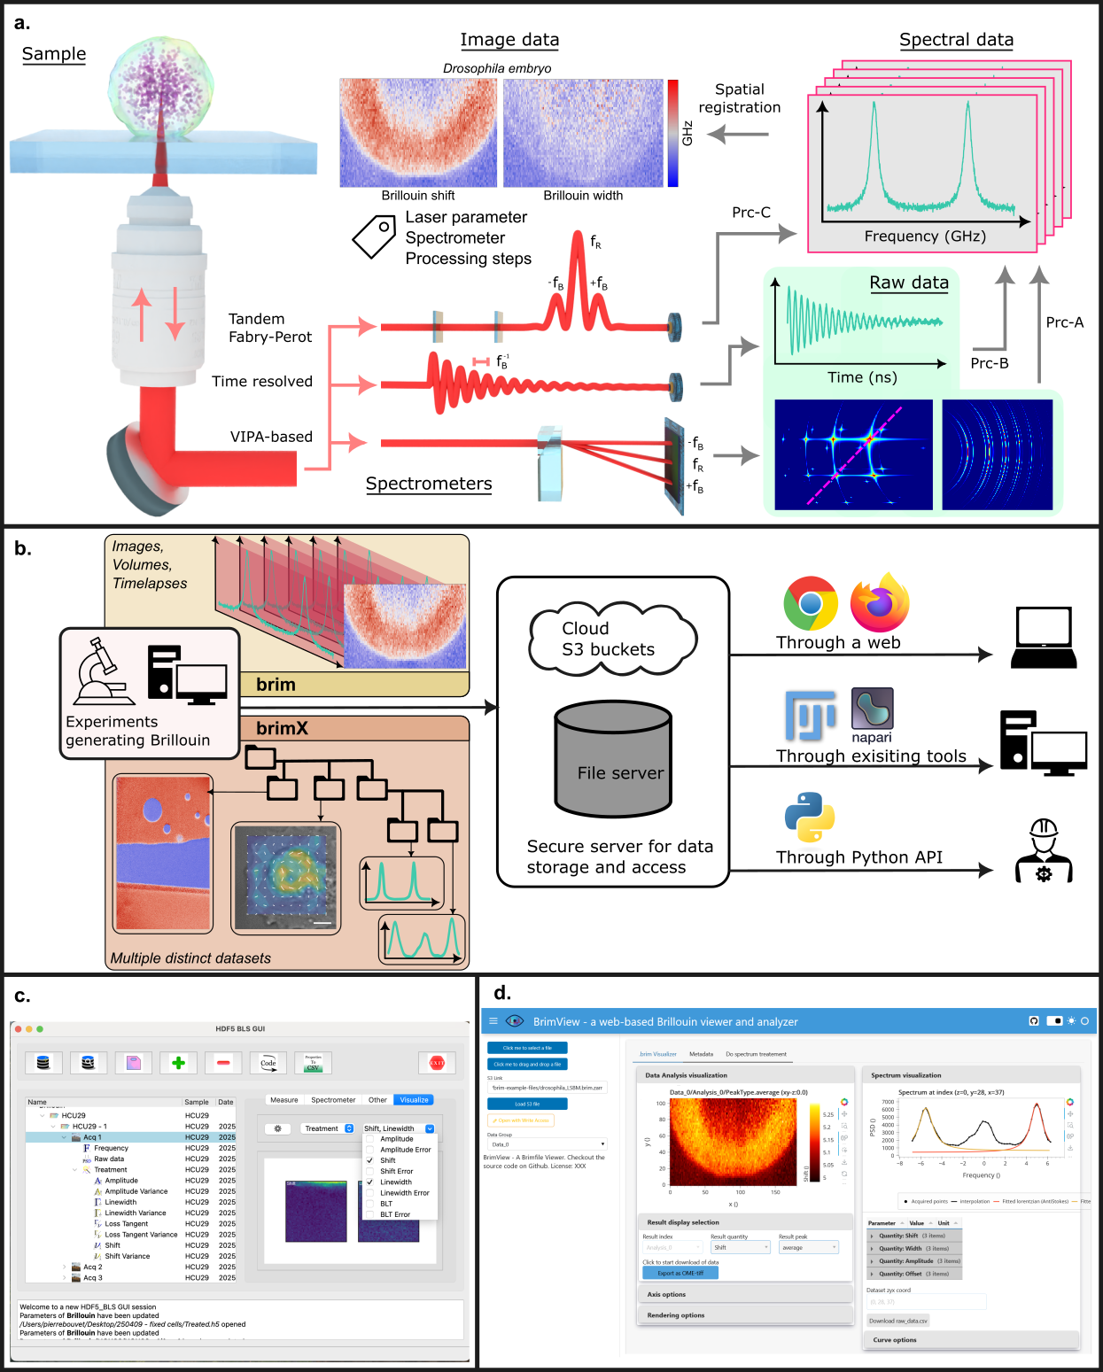
Fig. 1: A standardized file format and open-source analysis framework for Brillouin microscopy data. a) Overview of Brillouin light scattering data acquisition: A sample is illuminated by a narrowband laser, and the Brillouin scattered light is detected through a high-resolution spectrometer. Different spectrometer modalities produce different raw data that has to be converted into a calibrated and normalized spectrum through dedicated processing pipelines (Prc). This can then be processed into images and mappings of physical properties. b) Overview of the Brillouin data analysis pipeline: Brillouin data is saved either as individual .brim images or combined with others into a .brimX (for multi variable experiments). This file is then stored on a data server, from which users can access the recorded data either through cloud-native solution, e.g. S3 buckets, or more traditional means, e.g. a standard file server. The data can be opened through a custom, installationless web-app, through different existing software or with a python library/API. c) The HDF5-BLS GUI allows user-friendly creation of .brimX files. d) Overview of the BrimView GUI, a web-based app that opens .brim files and enables real-time data processing, exploration and visualization.

