Introduction
Brillouin Light Scattering describes the inelastic scattering of light by acoustic phonons. As an all-optical technique with the ability to retrieve mechanical information, this approach has seen a particular interest in biology in the recent years. Recently, a consensus statement has been released on the technique underlining the necessity for a new file format to unify the different modalities with the goal of comparing measures and performances of Brillouin spectrometers [1]. To this end we propose two new file formats: a file format built on HDF5 to unify all modalities from single spectrum acquisition to multidimensional mappings, oriented towards the researchers of the community, and a file format built on Zarr to store Brillouin hyperspectral images, oriented towards collaborators using Brillouin imaging as an established research modality [2].

Materials and methods
Both HDF5 and Zarr are hierarchical file formats that are structured in groups and datasets, and that allow users to store metadata together with any element of the file [3], [4]. Groups can store either other groups or datasets whereas datasets are used to store arrays of any dimension (tensors).
To account for the specific needs of the community and targeted audiences, custom Python libraries have been developed for both file structures: HDF5_BLS for the HDF5-based file format [5] and Brimfile for the Zarr-based file format [6]. The ability to export spatial hyperspectral Brillouin images stored in a HDF5 file format to Zarr file format has been implemented for seamless use of both solutions.
To further improve the creation of HDF5 files and the use by researchers outside the BioBrillouin community, two Graphical User Interfaces (GUIs) have been developed. Figure 1a shows a screen capture of HDF5_BLS_GUI, the GUI developed on top of the HDF5_BLS library. Figure 1b shows a screen capture of Brimview [7], a web application dedicated to displaying and reviewing Brillouin hyperspectral spatial images.
Discussion
The unification of the way data are stored in the community is a necessity for the evolution of the technique both in terms of repeatability and reliability that we propose to address with the presented solution. The solution we propose is still under development and would be greatly enriched by the feedback of the community. As such, we propose in this talk to describe our approach, the usability of the existing solutions we have developed and where the community can collaborate to establish this project as a solid basis for future developments, both academic with potential meta-analyzes performed between laboratories and industrial with new strategies for improving both the stability and reliability of the Brillouin spectrometers currently or soon-to-be commercialized.
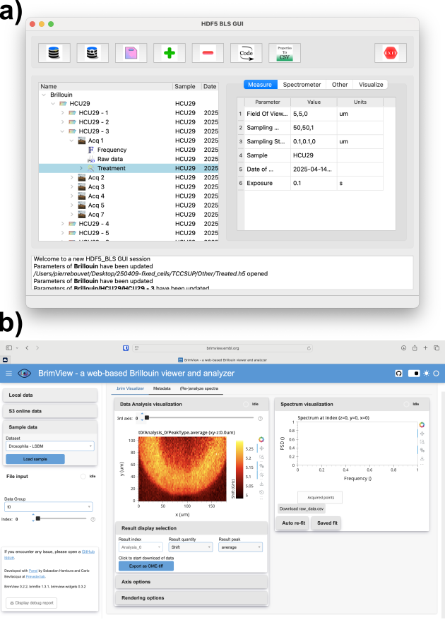
Figure 1 Screenshots of a) HDF5_BLS_GUI, the graphical user interface built on top of the HDF5_BLS Python library and b) Brimview, the web application to interface the proposed Zarr-based file formats

References
[1] P. Bouvet et al., Nat. Photonics, vol. 19, no. 7, pp. 681–691, July 2025, doi: 10.1038/s41566-025-01681-6.
[2] C. Bevilacqua et al., 2025, arXiv. doi: 10.48550/ARXIV.2509.07566.
[3] HDF5 Group, 2025. [Online]. Available: https://www.hdfgroup.org/solutions/hdf5
[4] Zarr Developers, 2025. [Online]. Available: https://zarr.dev
[5] P. Bouvet, GitHub. [Online]. Available: https://github.com/bio-brillouin/HDF5_BLS/tree/main
[6] C. Bevilacqua et al, 2025. [Online]. Available: https://github.com/prevedel-lab/brimfile
[7] C. Bevilacqua et al, [Online]. Available: https://brimview.embl.org

